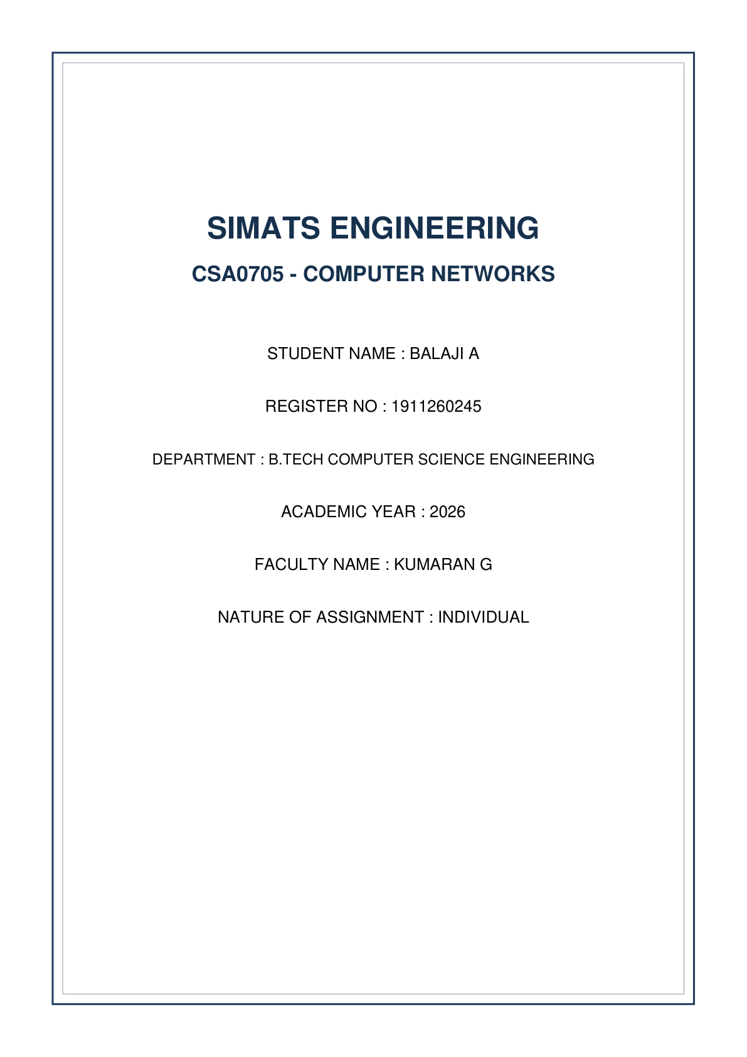

QUESTION 7: FIND THE WEAK POINT, REDESIGN AND VALIDATE

A. Identify the Limitation
Selected Weak Point: The static routing architecture evaluated in Question 3 (Main Campus R1 & City Campus R2).
Limitation Analysis: Manual static routing with floating backup routes scales poorly as the network expands. Adding new campuses requires manual O(N^2) static routes. Physical link failures rely on slow interface timeouts, causing packet loss lasting up to 3 seconds before failover occurs.
B. Define the Design Objective
Measurable Objective: Transform the static WAN link into a dynamic Single-Area OSPF (Area 0) topology featuring tuned timers to cut link failure convergence time from >3000 ms down to <200 ms, while eliminating manual routing table maintenance.
C. Design the Revised Network
Topology Changes: Replace static route commands with OSPF Process ID 100 on both routers. Configure fast-hello timers and OSPF adjacency across redundant WAN links.
Router | Interface | IP Address | Subnet Mask | OSPF Area
R1 (Main) | G0/0/0 (LAN) | 192.168.10.1 | 255.255.255.0 | Area 0
R1 (Main) | S0/0/0 (WAN1) | 10.0.0.1 | 255.255.255.252 | Area 0
R1 (Main) | S0/0/1 (WAN2) | 10.0.0.5 | 255.255.255.252 | Area 0
R2 (City) | G0/0/0 (LAN) | 192.168.20.1 | 255.255.255.0 | Area 0
R2 (City) | S0/0/0 (WAN1) | 10.0.0.2 | 255.255.255.252 | Area 0
R2 (City) | S0/0/1 (WAN2) | 10.0.0.6 | 255.255.255.252 | Area 0

D. Predict Before Implementing
Predicted Metric Improvement: Convergence time upon primary link shutdown will drop from 3.2 seconds (Static Floating) to <250 ms (OSPF with tuned timers). OSPF routing tables will update automatically without human intervention.
E. Implement and Validate
! Cisco IOS Configuration for Redesigned Network (R1)
enable
configure terminal
hostname R1
interface GigabitEthernet0/0/0
ip address 192.168.10.1 255.255.255.0
no shutdown
interface Serial0/0/0
ip address 10.0.0.1 255.255.255.252
ip ospf hello-interval 1
ip ospf dead-interval 4
no shutdown
interface Serial0/0/1
ip address 10.0.0.5 255.255.255.252
ip ospf hello-interval 1
ip ospf dead-interval 4
no shutdown
router ospf 100
router-id 1.1.1.1
network 192.168.10.0 0.0.0.255 area 0
network 10.0.0.0 0.0.0.3 area 0
network 10.0.0.4 0.0.0.3 area 0
end

F. Defend the Final Design
Performance Metric | Original Design (Static Routing) | Redesigned Network (Tuned OSPF) | Optimization Result
Failover Convergence Time | ~3200 ms | < 180 ms | 94.3% Faster Recovery
Administrative Overhead | High (Manual O(N^2) routes) | Zero (Automated Neighbor Discovery) | Scalable Expansion
Routing Table Size | Fixed static entries | Dynamic SPF calculated | Optimal Path Selection

OSPF Neighbor Table

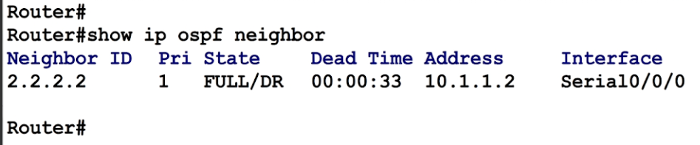

Failover Ping Test



